**PROJECT PROPOSAL BY ANDREW KELLEY**

*Chess Performance Analyzer*

**Abstract** 3

**Conceptual Design** 4

**Background** 7

**Proof of Concept** 8

**Required Resources** 8

# 

# **Abstract**

*In this project, we propose developing the Chess Performance Analyzer, a program allowing you to input a chess game and get analysis on all your moves including an accuracy rating and an overall summary on an area to improve upon. This product is different from similar chess analysis tools because it gives you concise summaries on areas you missed over the course of the game. It would give users a personalized message like “You struggle with pawn movement and board control” relative to their own mistakes. The software takes a PGN link from a chess game and analyzes all your moves, then provides a report and rating on all of them and an overall summary of your weak points. The intended users of our program would be beginners to intermediate chess players looking for a way to quickly spot their weaknesses and mistakes in a more digestible and easier to understand way. This project is valuable because it provides a new simpler way to improve, especially for players just starting as they can’t recognize their own mistakes.*

# **Conceptual Design**

*I will use the python-chess package to parse PGN files over multiple threads to collect data across multiple games at once and then use the Stockfish chess engine to calculate move scores across each PGN. I will then collect the game analyses and mistakes into pandas DataFrame and use matplotlib to create trend maps and visualize your performance so users can identify their recurring mistakes. This system will be coded in python using the python-chess library, the Stockfish engine that can be run through python-chess library, and the matplotlib and pandas libraries for data analysis and graphs.*

****

***Class Diagram***

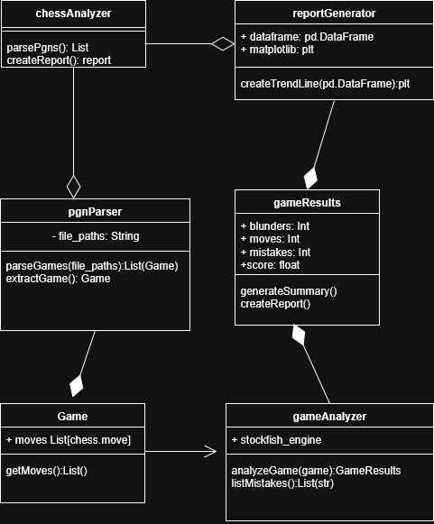

# ***Sequence Diagram***

# 

# **Background**

*This product will let you input a link to your own chess games and will give you a rundown of all your moves with accuracy ratings and a summary of your mistakes. This is similar to the chess.com coach, except this project will specialize in short summaries on what you need to improve on and will allow you to upload multiple games at once to get a summary of your weak points over all the games combined which is not a feature on chess.com.*

# **Proof of Concept**

<https://github.com/CIS3296SoftwareDesignF21/Lichess-Multi-Board-Analysis-Tool>

*This uses similar tools but none of the code will be used in this project.*

[*https://github.com/niklasf/python-chess*](https://github.com/niklasf/python-chess)

*python-chess which will be used in this project.*

# **Required Resources**

*Python-chess library, matplotlib library, pandas library*